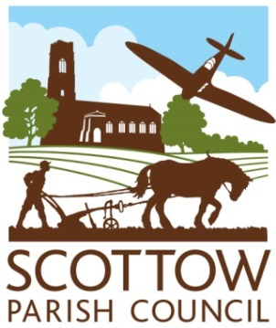
SCOTTOW PARISH COUNCIL
AGENDA
North Walsham Rugby Club
July 8th. 2026 at 7.00p.m.

Members, you are summoned to attend a Parish Council Meeting on 8th July 2026 at 7.00pm
Members of the public and the press are welcome to attend.
Open session for members of the public to speak – 2 minutes per person.
AGENDA
- Apologies for Absence
- Declaration of Interests and requests for dispensations
- To consider and approve the minutes of the Annual Parish Council meeting held on May 20th.2026
- Clerk’s report and update on items from the minutes
- County & District Councillor Reports

- FINANCE AND GOVERNANCE
- To consider the present financial position(previously circulated)
- To consider and resolve whether to approve invoices for payment

- PLANNING
  - To consider new planning applications
b. To notify of any planning decisions by NNDC
c. To consider any other planning issues
To consider complaints regarding a portable toilet and shipping container on 13 Scottow Row.

- HIGHWAYS MATTERS
  - Update.

- CEMETERY MATTERS
  - Update on recent burials and internments
  - Update on marketing folders and leaflets and website page
  - Update on grounds maintenance – hedges, trees, pipes, watering & weed control
  - New date for Chapel works – 19th July. To consider purchasing paint, oil etc. for the Chapel.
  - To consider an A4 Flyer to be delivered to all residents to advertise the Cemetery. Proposed cost for 1000 leaflets is £64.87 plus delivery.

- B1150 Special Interest Group
To consider if Scottow Parish Council should be represented on this group.

- To consider supplying a Doggie Bin by the bus shelter, Park Avenue

Contact the Clerk: scottowpc@gmail.com or telephone 01692 538971

