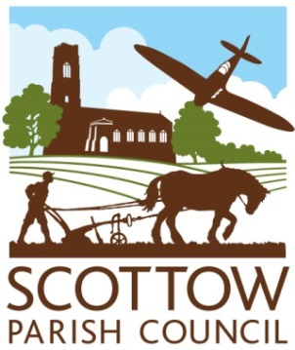
SCOTTOW PARISH COUNCIL
ANNUAL PARISH COUNCIL Meeting
AGENDA
THE BATTLE OF BRITAIN HALL
20th MAY 2026
7.30pm
(This meeting will follow the Annual Parish Meeting, therefore start time is approximate)

Members you are summoned to attend the Annual Parish Council Meeting
Members of the public and the press are welcome to attend.

- The Election of the Chairman & Acceptance of Office
- Apologies for Absence
- Declaration of Interests in Items on the Agenda
- The Election of the Vice Chairman & Acceptance of Office
- To consider and approve the Minutes of the meeting held on March 11th 2026
- Clerk’s report and update on items from the Minutes

FINANCE AND GOVERNANCE
- To consider the present financial position (circulated)
- To consider and resolve whether to approve outstanding invoices for payment
- To approve the Annual Governance Statement 2025/26
- To approve the Accounting Statements 2025/26
- To agree the dates for the Period for the Exercise of Public Rights (June 3rd to July 14th)
- To appoint the Responsible Finance Officer for 2026/27

PLANNING
- To consider any planning applications
- To notify of any Planning Decisions by NNDC
- To consider any other Planning Issues
- Update on Oddfellows Barn

- Highways update
To agree what has been resolved and to report on continuing problems.

- Community Woodland
To consider what action can be taken to speed up access to the Community Woodland

- Cemetery Matters
- To consider increasing the fees for burials and internments.
- To consider and approve the advertising material and the costs.
- To consider the watering of the trees and a proposal to purchase water bags to facilitate this.
- To consider the problems caused by moles on the cemetery.
- To agree a date for repairs to, and painting of, the inside of the chapel

- Correspondence
To consider any correspondence received.

Gill Kimmerling Clerk
scottowpc@gmail.com

