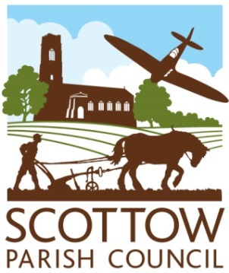
SCOTTOW PARISH COUNCIL
AGENDA
North Walsham Rugby Club
NOVEMBER 12th.2025 at 7.00p.m.

Members, you are summoned to attend a Parish Council Meeting on 12th November 2025 at 7.00pm
Members of the public and the press are welcome to attend.

Open session for members of the public to speak – 2 minutes per person.

AGENDA
- Apologies for Absence
- Declaration of Interests and requests for dispensations
- To consider and approve the minutes of the Parish Council meeting held on 10th September 2025 and the Extraordinary Parish Council meeting held on October 29th 2025
- Clerk’s report and update on items from the minutes
- County & District Councillor Reports

- FINANCE AND GOVERNANCE
- To consider the present financial position(previously circulated)
- To consider and resolve whether to approve invoices for payment
- To consider and approve Clerk’s hours and salary for 2026/27
- To consider and approve Chair’s allowance for 2026/27
- To consider and set the Precept for 2026/27

- PLANNING
  - To consider new planning applications
PF/25/2356 24, Barton Road, Badersfield – Replacement windows
b. To notify of any planning decisions by NNDC
c. To consider any other planning issues.

- Highways update
  - Update on bus shelter.
  - To consider on-going problems – Missing HGV sign Scottow Row/Church Lane crossroads and pot holes in Scottow Row.
- Cemetery update.
  - To confirm a timeframe for the benches with Mr. Hindle
  - To report on maintenance day at the cemetery and to consider painting the interior of the chapel in the Spring.
- Next meeting – January 21st 2026 at 7p.m. at the Rugby Club

Contact the Clerk: scottowpc@gmail.com or telephone 01692 538971

