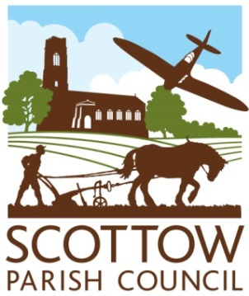
SCOTTOW PARISH COUNCIL
AGENDA
North Walsham Rugby Club
January 15th.2025 at 7.00p.m.

Members, you are summoned to attend a Parish Council Meeting on 15th January 2025 at 7.00pm
Members of the public and the press are welcome to attend.

Open session for members of the public to speak – 2 minutes per person.

AGENDA
- Apologies for Absence
- Declaration of Interests and requests for dispensations
- To consider and approve the minutes of the Parish Council meeting held on 13th NOVEMBER 2024
- Clerk’s report and update on items from the minutes
- County & District Councillor Reports

- FINANCE AND GOVERNANCE
- To consider the present financial position(previously circulated)
- To consider and resolve whether to approve invoices for payment
- To consider and set the Precept for 2025/6

- PLANNING
- To consider new planning applications
RV/24/2606 Scottow Enterprise Park- Change of use of existing buildings
2. To notify of any planning decisions by NNDC
3. To consider any other planning issues.

- To report on changing to the website to Norfolk ALC

- Highways update

- Cemetery update
  - To consider setting up a meeting with Nick Hindle to discuss the central memorial feature.
  - Update on cemetery matters.

- To set the dates for meetings in 2025/6
March 11, May 14, July 9. Sept 10, Nov 12, Jan 21 2026

- To consider a combined litter pick with Swanton Abbott Parish Council in March

